2023
toolsforpolyploids@tamu.edu
Twitter: @polyploidtools

Tools for Polyploids Workshop Travel Guide
Contents
Public Transportation 2
Trolley Map 3
Parking on Campus 4
Hotels Near SDSU 5
Travelling from PAG to Tools for Polyploids 6

Public Transportation
The San Diego Metropolitan Transit System (MTS) is the trolley system that runs throughout the city and stops right outside the Conrad Prebys Aztec Student Union Center on San Diego State University’s campus where the workshop will be held. The Sycuan Green Line runs alongside campus and the SDSU Station is the stop for the student union center. A complete map of each line and its stations are pictured on the next page. You can even use the Trip Planner feature on their website to put in your location, find the closest station, and get a schedule for your trolley! Visit the MTS website for more information on fares, maps, and stations.

Fares
One-way tickets are $2.50USD each. PRONTO is an app for your smartphone that allows you to load money onto your digital trolley card instead of purchasing a physical card to use on the trolley. If you prefer a physical card, they can be purchased at every trolley station at ticket machines. For more information, visit this page on the MTS website.

Parking at Trolley Stations
Several of the trolley stations offer free parking in case you are in driving-distance of the closest station. Visit the Transit Station Parking page here to see a complete list of stations with parking lots. Parking at any trolley station is limited to 24 hours. Street or paid parking may be available at stations not listed on this page.

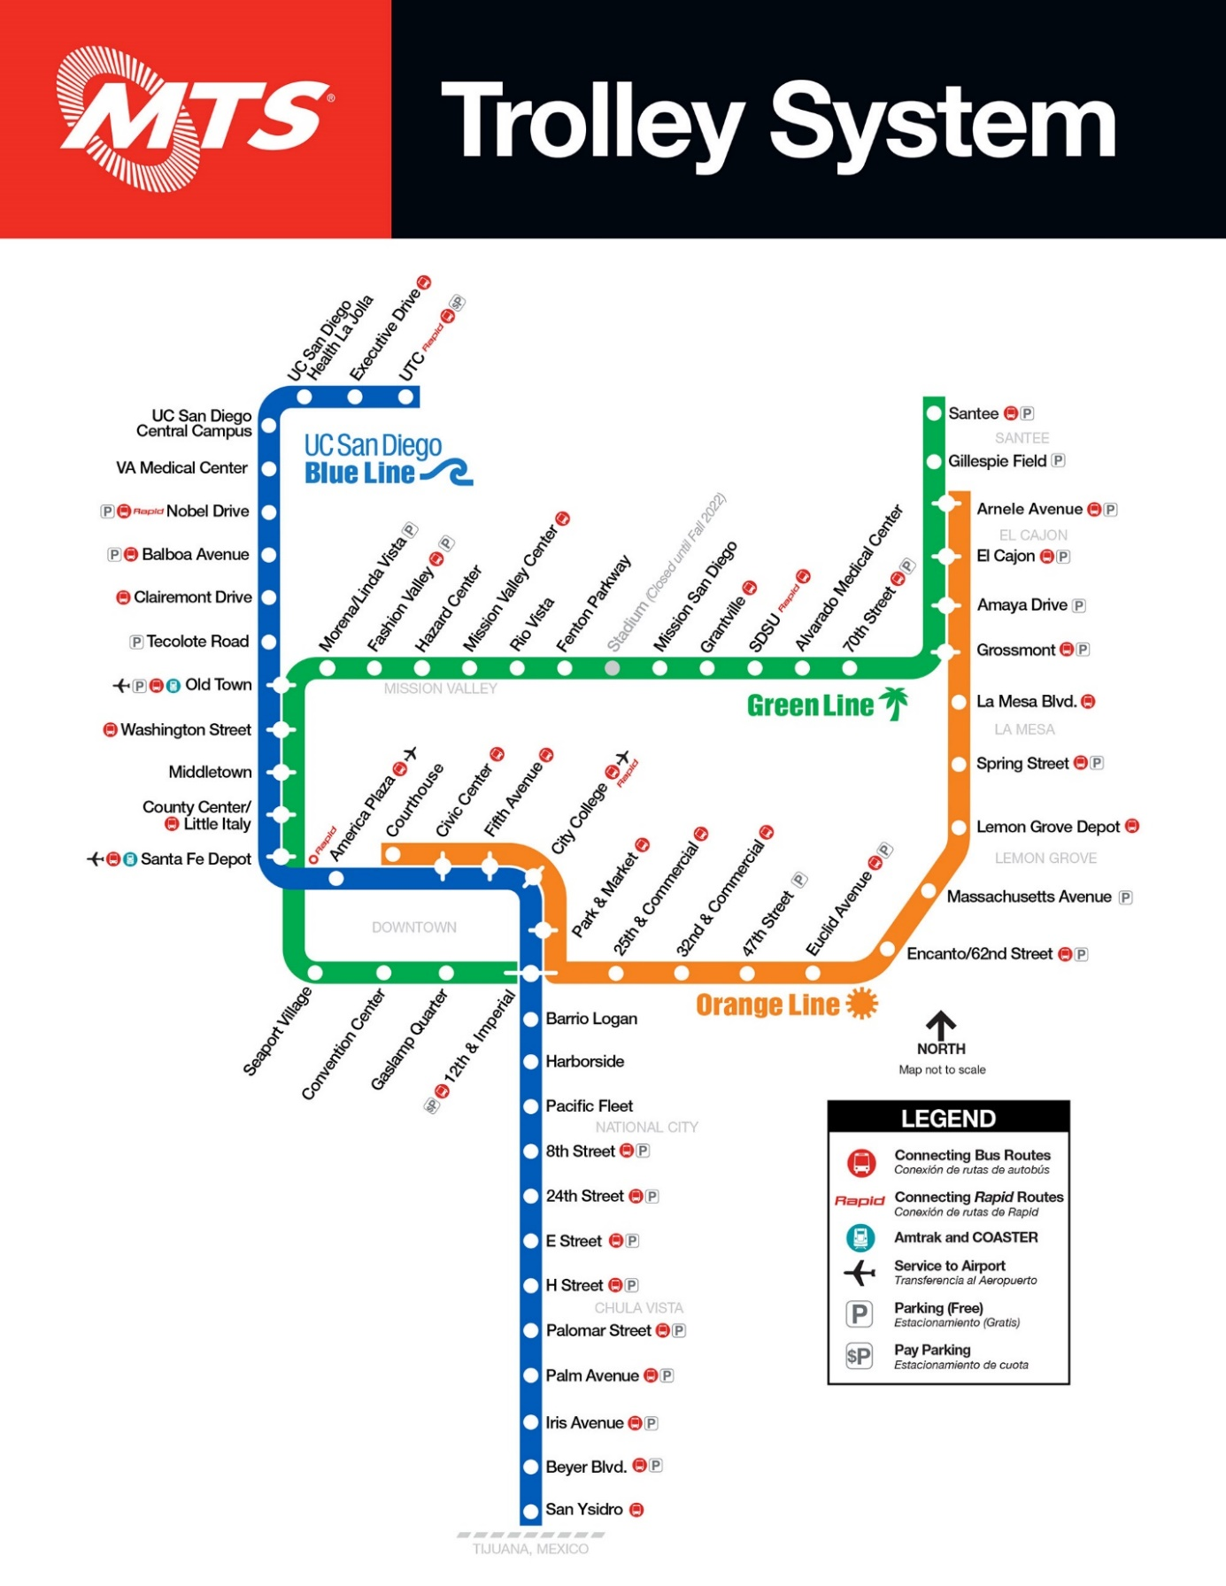
Trolley Map

Parking on Campus
If you are driving to campus each day, the closest parking garage to the Conrad Prebys Aztec Student Union is Parking Garage 3 at Zura Way, San Diego, CA 92115. Once you exit the parking garage, cross East Campus Drive to Aztec Walk East. Once you reach Tepeyac Residence Hall on your right, turn right to cross the footbridge over College Avenue and the student union center is straight ahead! The whole walk is about 7 minutes long. A map with walking directions from the garage to the student union center is pictured below. Visitor parking is allowed on all levels of Parking Garage 3 but visitors can not park in spaces labelled
- F/S (Faculty/Staff)
- S/V (Service/Vendor)
- SP (Special Permit)
- EV (Electric Vehicle) unless you are actively charging an electric vehicle
- DP (Disabled Person) unless you hold a valid DMV placard/plate for disability parking
Pay stations are located on the first floor of this garage and require credit/debit cards or exact cash only (no change will be given). Simply go to the pay station, select the amount of time you would like to park, enter your license plate information, and pay! If you are using a credit card, you have the option to enter your cell phone number to receive a test when your time is about to expire and extend your time. For more information on pay stations, visit the Parking and Transportation page.
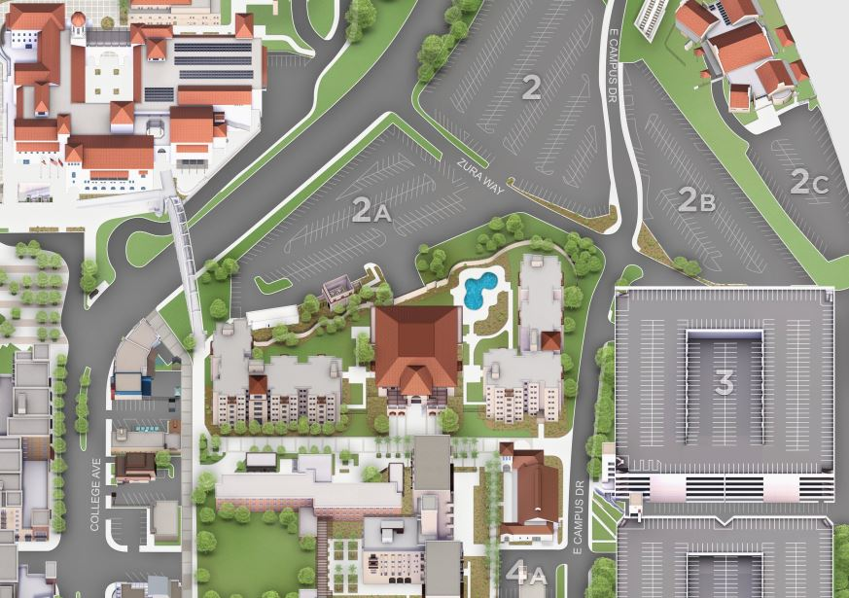
There is also an option to pay to park using the PayByPhone smartphone app. Available to both iPhone and Android users, this app allows you to create an account and enter your car’s information to park without using a pay station. Each parking garage has a code you enter on the app that secures your spot in the lot. Enter the location number that is posted at the entrance (Parking Garage 3’s code is 28503), select how long you would like to park, confirm and pay! It will automatically connect your license plate number to a virtual parking pass. This app also notifies you when your time is about to expire and gives you the option to extend your time if needed. You can read more about the app here.

Hotels Near SDSU
Below is a list of hotels located near San Diego State University. Use the links below to check availability and prices.
- Days Inn by Wyndham – Mission Valley
  - https://www.wyndhamhotels.com/days-inn/san-diego-california/days-inn-mission-valley-qualcomm-stadium-sdsu/overview?CID=LC:DI:20160927:RIO:Local:SM-dipaci&iata=00093796
- Days Inn and Suites by Wyndham – San Diego SDSU
  - https://www.wyndhamhotels.com/days-inn/la-mesa-california/days-inn-and-suites-san-diego-sdsu/overview?CID=LC:DI:20160927:RIO:Local:SM-dipaci&iata=00093796
- Lamplighter Inn and Suites at SDSU
  - https://www.lamplighter-inn.com/?utm_source=google%20my%20business&utm_medium=listing&utm_campaign=visit%20website
- Holiday Inn San Diego – La Mesa
  - https://www.ihg.com/holidayinn/hotels/us/en/la-mesa/sanpd/hoteldetail?cm_mmc=GoogleMaps-_-HI-_-US-_-SANPD

Travelling from PAG to Tools for Polyploids
If you are also attending the Plant and Animal Genome Conference (PAG), it is not far from San Diego State University where the Tools for Polyploids workshop will be held. From the PAG conference center to the parking garage closest to the student union center is an 11-minute drive or a 30-minute ride on the Green Line via trolley (see Public Transportation map on page 3).
For driving instructions to the parking garage, use “SDSU Parking Structure 3, Zura Way.” From there, you can use the walking instructions from the parking garage to campus listed on page 4. Below is a link to Google Maps driving instructions from PAG to the parking garage.
Driving instructions: https://goo.gl/maps/bZZRzU7wC2rYZaBw9
If you plan to use the trolley line from the PAG conference center, the closest trolley station is the Fashion Valley Station located at 1205 Fashion Valley Road and is only a 10-minute walk. From the Fashion Valley Station, you will have seven stops before reaching the SDSU Station which is located just outside the Conrad Prebys Student Union Center. Below is a link to Google Maps instructions for taking the trolley system to the student union center.
Green Line to SDSU’s campus instructions: https://goo.gl/maps/CXBFDwZBr1ogfMJe9

